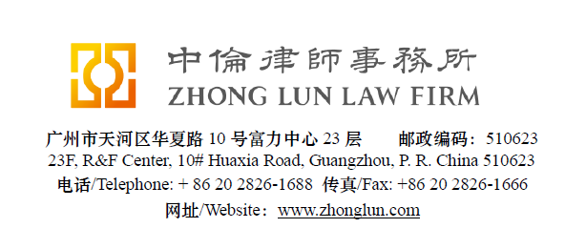

Invoice / 收款通知书

|  |  |  |  |
| --- | --- | --- | --- |
| **Date**  **日期** | 28/07/2019 | **ZL Invoice Reference[1]**  **中伦收款通知编号** | 062901-0001/022 |
| **Client**  **客户** | | **Payoneer Inc.**  Attn: Bart Rubin  150 West 30th Street, Suite 600  New York, NY 10001 | |
| **Subject Matter**  **事项** | General | **Service Period**  **服务期限** | June 2019 |
| **Legal Fee**  **律师费** | USD 11,416 | **Reimbursement**  **报销费用** |  |
| **Sum Now Due[2]**  **总应付款** | USD 11,416 | | |

Please make the payment to the banks account as follows:

请将上述款项付至下列账户：

|  |  |  |  |
| --- | --- | --- | --- |
| **Account Number**  **账号** | 1209 0403 9310 502 | **Swift Code**  **银行代码** | CMBCCNBS131 |
| **Account Name[3]**  **账户名称** | Beijing Zhong Lun Law Firm Guangzhou Office  北京市中伦（广州）律师事务所 | | |
| **Bank Name**  **开户行** | China Merchants Bank, Guangzhou Branch, R&F Center Subbranch  招商银行广州分行富力中心支行 | | |
| **Address**  **地址** | 2/28F R&F Center, 10 Huaxia Road, Guangzhou, China  广州市华夏路10号富力中心2/28楼 | | |

**Zhong Lun Law Firm 中伦律师事务所**

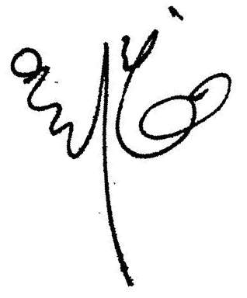

**Charge Details/收费明细**

To our Professional Charges for our service rendered in respect of the following:

中伦律师事务所就如下事宜提供了专业服务：

| **Date  日期** | **Description of Services 服务记录** | **Personnel 人员** | **Hours Spent 所用小时数** |
| --- | --- | --- | --- |
|  |  |  |  |
| 03/06/19 | Confirming the signed Annual Sponsorship with Gulu to client. | Debby Z | 0.3 |
|  |  |  |  |
| 04/06/19 | Confirming the signed Sponsorship Contract for Yiwu 615 Cross-border Event to client. | Debby Z | 0.4 |
|  |  |  |  |
| 10/06/19 | Reviewing the comments on the Letter of Commitment for a free Amazon event in Taiwan prepared by Debby ZHOU. | Kent W | 1.1 |
|  |  |  |  |
|  | Preparing the note on the letter of commitment for a free event in Taiwan with Amazon and further preparing the note on disclosing information to Amazon and sending the same to client. | Debby Z | 2.5 |
|  |  |  |  |
| 13/06/19 | Reviewing the comments on the Cif News Annual Media Package Agreement and its summary in English prepared by Debby ZHOU. | Kent W | 1.0 |
|  |  |  |  |
|  | Reviewing the Cif News Annual Media Package Agreement and preparing the summary in English and sending the same to client. | Debby Z | 2.4 |
|  |  |  |  |
|  | Proofreading the Chinese translation of the added English in Annex 1 of Payouts for Accountholders Agreement and replying the email of client. | Helen W | 0.3 |
|  |  |  |  |
| 14/06/19 | Reviewing the comments on the Sponsorship Contract for 621 Yiwu WISH Event and its summary in English prepared by Debby ZHOU. | Kent W | 1.2 |
|  |  |  |  |
|  | Reviewing the Sponsorship Contract for 621 Yiwu WISH Event and preparing the summary in English and sending the same to client. | Debby Z | 2.9 |
|  |  |  |  |
| 15/06/19 | Confirming the signed Sponsorship Contract for 621 Yiwu WISH Event to client. | Debby Z | 0.3 |
|  |  |  |  |
| 16/06/19 | Reviewing the comments on the Venue Rental Contract of 2019 Shenzhen Forum prepared by Debby ZHOU. | Kent W | 1.8 |
|  | Reviewing the Venue Rental Contract of 2019 Shenzhen Forum and preparing the note on the same and sending the same to client. | Debby Z | 4.9 |
|  |  |  |  |
| 17/06/19 | Reviewing the updated Cif News Annual Media Package Agreement and confirming the same to client. | Debby Z | 0.3 |
|  |  |  |  |
| 19/06/19 | Confirming the signed Cif News Annual Media Package Agreement to client. | Debby Z | 0.3 |
|  |  |  |  |
| 20/06/19 | Reviewing the updated Venue Rental Contract of 2019 Shenzhen Forum and updating the same to client. | Debby Z | 1.5 |
|  |  |  |  |
| 21/06/19 | Reviewing the comments on the Sponsorship Contract with Chinese Business Journal and its summary prepared by Debby ZHOU. | Kent W | 1.2 |
|  |  |  |  |
|  | Reviewing the Sponsorship Contract with Chinese Business Journal and preparing the summary in English and sending the same to client. | Debby Z | 2.7 |
|  |  |  |  |
| 23/06/19 | Reviewing the comments on the Sponsorship Contract for Shopee Operation Manuel and its summary in English prepared by Debby ZHOU. | Kent W | 1.5 |
|  |  |  |  |
|  | Reviewing the Sponsorship Contract for Shopee Operation Manuel and preparing the summary in English and sending the same to client; and further reviewing the updated Venue Rental Contract of 2019 Shenzhen Forum and preparing the note on the same to client. . | Debby Z | 3.6 |
|  |  |  |  |
| 24/06/19 | Reviewing the comments on the Sponsorship for Hefei Event and its summary in English prepared by Debby ZHOU. | Kent W | 0.7 |
|  |  |  |  |
|  | Reviewing the Sponsorship for Hefei Event and preparing the summary in English and sending the same to client. | Debby Z | 1.8 |
|  |  |  |  |
| 25/06/19 | Reviewing the updated Sponsorship Contract with Chinese Business Journal and confirming the same to client. | Debby Z | 0.6 |
|  |  |  |  |
| 26/06/19 | Confirming the signed Sponsorship Contract for Hefei Event and the updated Venue Rental Contract of 2019 Shenzhen Forum to client. | Debby Z | 1.1 |
| 27/06/19 | Confirming the signed Sponsorship Contract with Chinese Business Journal to client. | Debby Z | 0.3 |
|  |  |  |  |

For clarification we have set out below a table showing the hours spent by ZL personnel:

为明确起见，我们在下表中列明了中伦律师事务所工作人员所花费的时间：

|  |  |  |  |
| --- | --- | --- | --- |
| **Personnel**  **人员** | **Hours Spent**  **总计小时数** | **Rate (USD)/hour**  **每小时费率** | **Legal Fee (USD)**  **律师费** |
|  |  |  |  |
| Kent WOO | 8.5 | 480 | 4,080 |
|  |  |  |  |
| Debby ZHOU/Helen WONG | 26.2 | 280 | 7,336 |
|  |  |  |  |
|  |  | **Totals/合计:** | **11,416** |

1. **Please kindly indicate the ZL Invoice Reference number on your bank processing document and provide us a copy of the bank confirmation for the payment. /请在银行付款单据上标明中伦收款通知编号，并向我方提供相关银行确认书。**
2. **Please pay equivalent foreign currency if a USD account is not available. /若未能支付美元，请支付等值外币。**
3. **Please indicate the FULL name in the bank advice and state the FULL name at the remark or note section on the bank advice./ 请在银行付款单据上列明全称并在汇款附言或备注栏填入收款人全称。**